**SUNWAY UNIVERSITY SCHOOL OF ENGINEERING AND TECHNOLOGY**

|  |  |
| --- | --- |
| **Subject Code and Title:** | WEB1201 WEB FUNDAMENTALS |
| **Semester:** | August 2022 |

WEB FUNDAMENTALS REPORT DEADLINE: 30/11/2022



|  |  |
| --- | --- |
| Lecturer Name: | Dr. Steven Eu Kok Seng |
| Tutor Name: | Mr. David Alebiosu |
| Tutorial Group: | 5 |
| Student Name: | Elena Khoo Sze Kay |
| Topic Chosen: | Educational |

Academic Honesty Acknowledgement

“I Elena Khoo Sze Kay (Name) verify that this paper contains entirely our own work. I have not consulted with any outside person or materials other than what was specified (an interviewee, for example) in the assignment or the syllabus requirements. Further, I have not copied or inadvertently copied ideas, sentences, or paragraphs from another student. We realize the penalties (refer to the student handbook diploma and undergraduate programme) for any kind of copying or collaboration on any assignment.” Elena Khoo 30/11/2022 (Student’s Signature / Date)

|  |  |  |  |  |
| --- | --- | --- | --- | --- |
| **No.** | **Student Full Name** | **Student ID** | **Program Code** | **Signature** |
| **1** | Elena Khoo Sze Kay | 21012570 | BCNS | **Elena Khoo** |

# 

TABLE OF CONTENTS

1.0 INTRODUCTION 1

1.1 AIMS & OBJECTIVES 1

1.2 REQUIREMENTS 1

2.0 DESIGN LAYOUT 3

2.1 GENERAL DESIGN 3

3.0 IMPLEMENTATION DETAILS 43

3.1 IMPLEMENTATION TABLE 43

4.0 TEST CASES & RESULTS 44

5.0 REFERENCES 50

# 

# 

# INTRODUCTION

### 1.1 AIMS & OBJECTIVES

The aim of creating this website is to alert people all around the world that climate change is a very serious matter, therefore urgent action is required to fight climate change and its effects. Climate Action is the 13th goal in sustainable development goals created by the United Nations. This website's goal is to raise public awareness about climate change and to inform visitors that climate change is harmful and has a lot of negative consequences.

## 1.2 REQUIREMENTS

All requirements in the project guidelines are included on the website. HTML, CSS, and JavaScript were used on the website. The website is responsive as it includes different displays such as images, labels, textboxes, buttons, links, and the navigation bar. This website includes a login page, sign up page, home page, emissions page, goals page, current actions page, 2030 page and contact us page. After the completion of the website, the website is then published on 000webhost which is a free web-hosting site and GitHub which is an online repository.

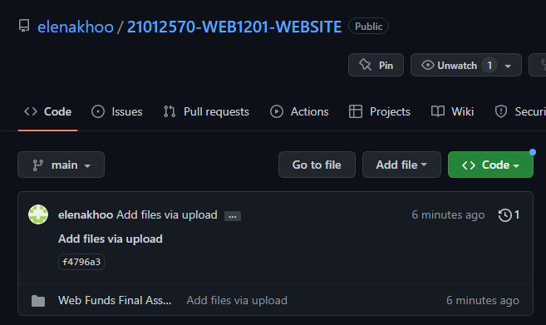

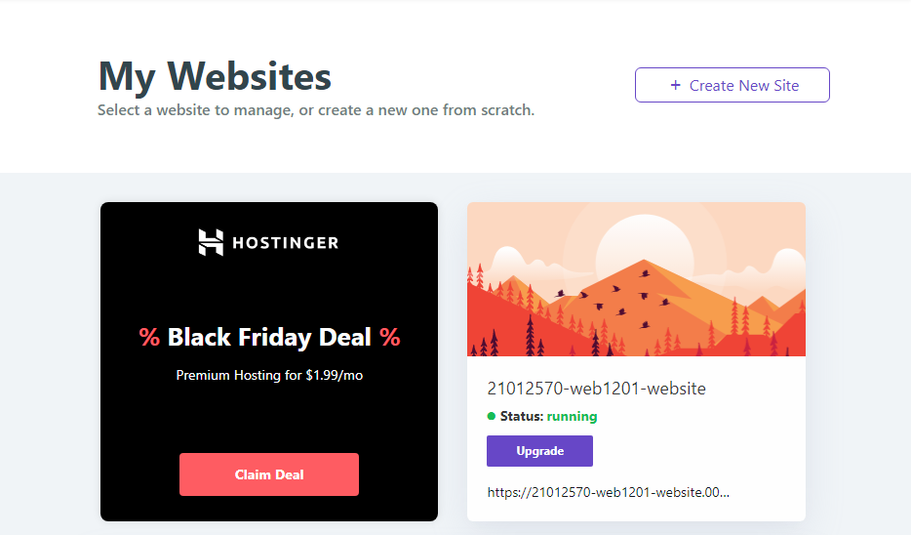

# 2.0 DESIGN LAYOUT

## 2.1 GENERAL DESIGN

A general theme on the website is to use the colour green, a background picture for each page following with a white background to display the information. The placement of the navigation bar is easy and convenient for the user to navigate and visit each page. Furthermore, images, labels, textboxes, buttons, links were added on the website. In all pages, the climate action logo is there. Users could also click on the logo to return to the home page. In addition, this website is fully responsive in different viewports as well as the content getting larger as the width of the screen is smaller.

# 2.2 DESIGN FRAMEWORK

Login Page

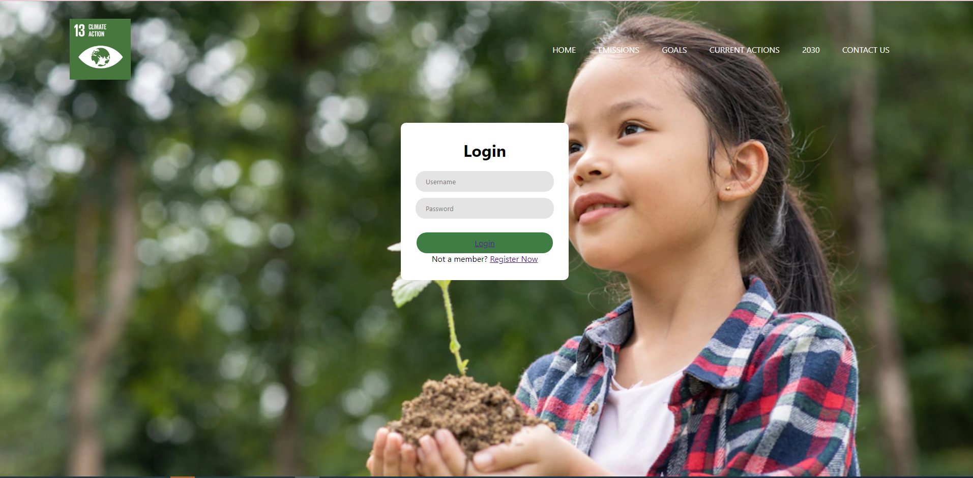

Login Page on PC

The picture above shows the login page which includes the viewer to log in to the page to view the whole website. The user will have to enter their username and password to log in. If the viewer does not have an account, they will have to click the register now button below which is linked to the sign-up page.

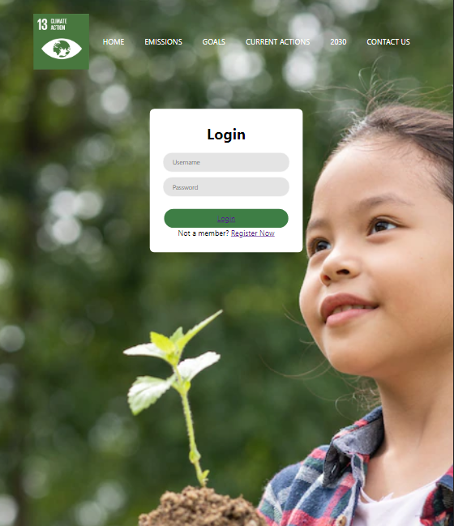

Login Page on Mobile

Sign Up Page

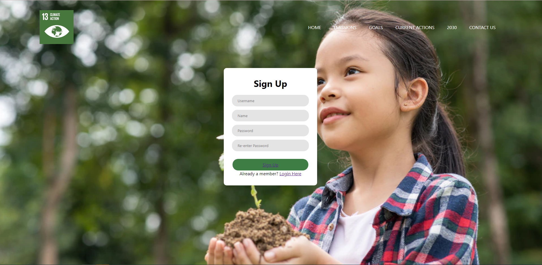

Sign Up Page on PC

Above shows the sign-up page. The sign-up page has the same layout as the login page as it is related with each other. This page has more inputs than the login page as the user will need to create a new account which includes their username, name, password, and a re-enter of their password. If the user clicks the register now button on accident, the user can simply just click the login here button back to log in.

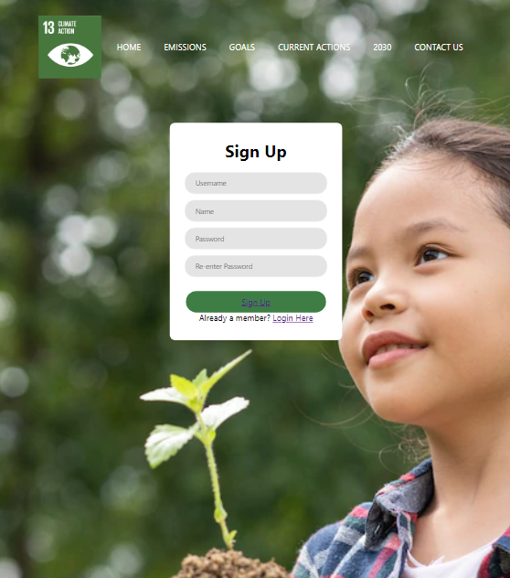

Sign Up Page on Mobile

Home Page

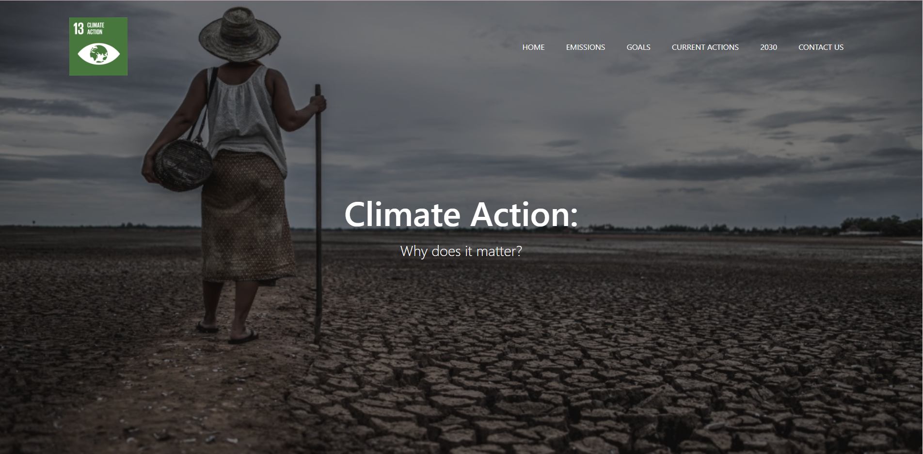

Home Page on PC

The picture above shows the home page of the website. A full screen layout was made to capture the audience’s attention towards the image which shows the main and subtopics of the website. The image has been chosen to show how climate change has affected us and the environment. A navigation bar is created for the convenience of the user to navigate between pages and goal 13's "Climate Action" emblem is in the upper left corner. The user can also click on the logo to return to the home page for easy access.

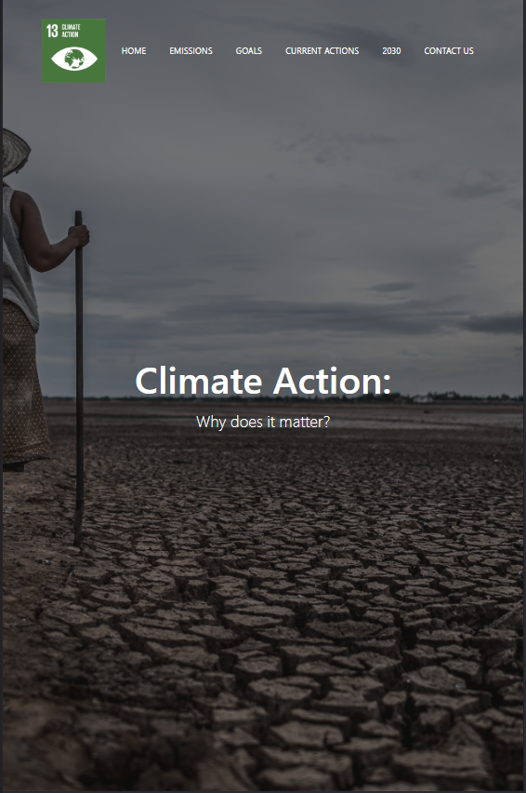

Home Page on Mobile

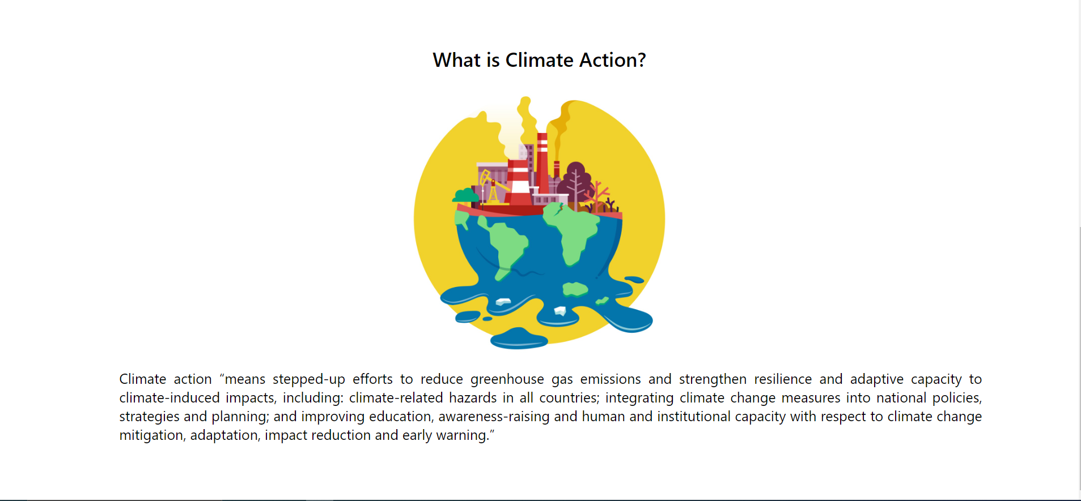

Home Page on PC

This page is the continuation from the home page. The picture shown above explains what climate action is. The picture above was chosen to explain how climate change affects the environment.

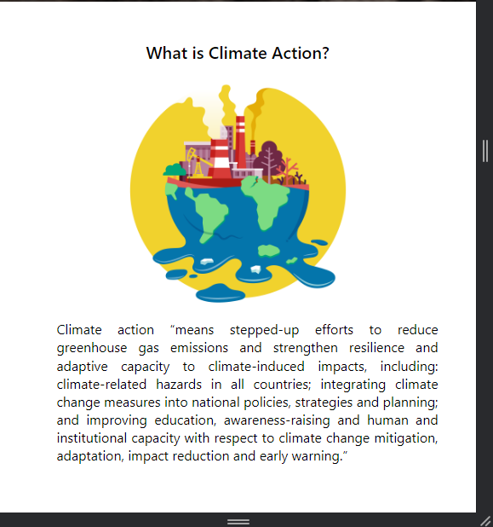

Home Page on Mobile

Emissions Page

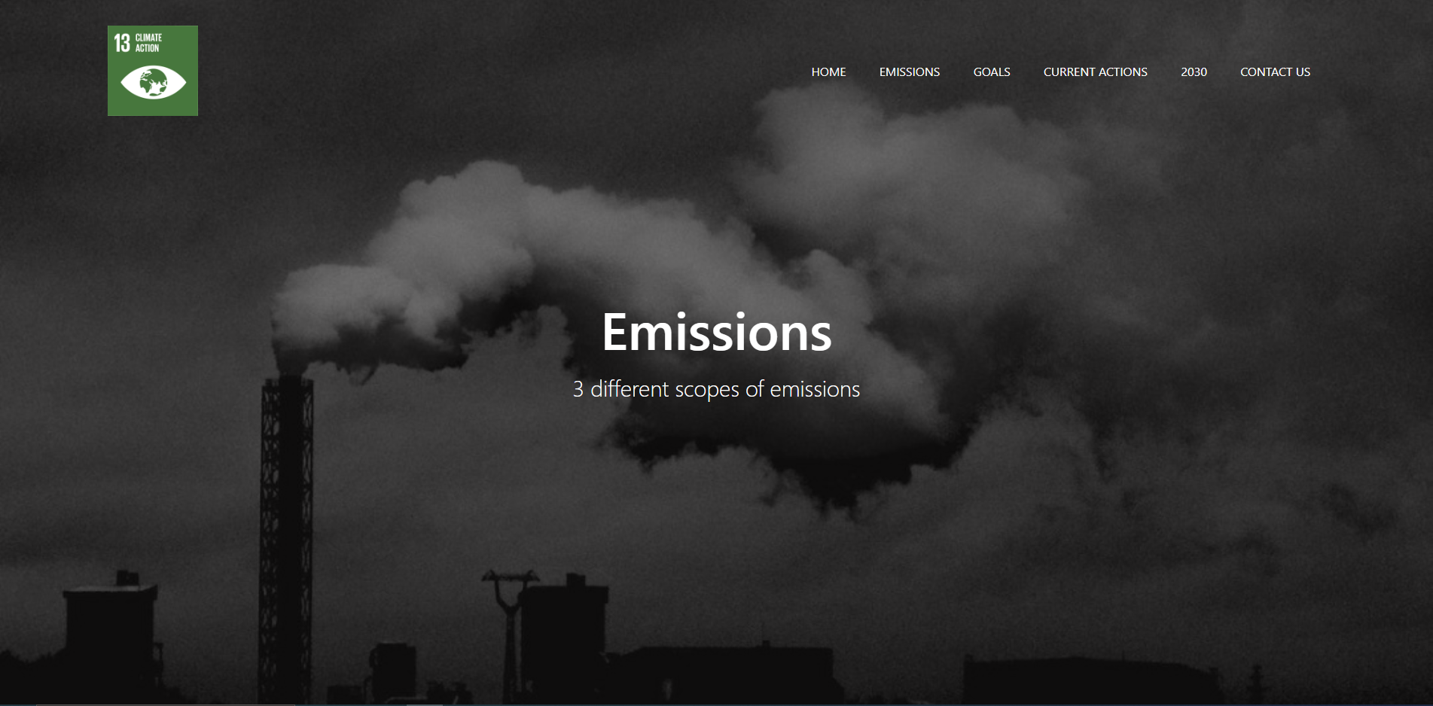

Emissions Page on PC

The image above shows the emission page of the website. This image illustrates how seriously emissions have impacted our ecosystem. On this page, three different scopes of emission will be explained.

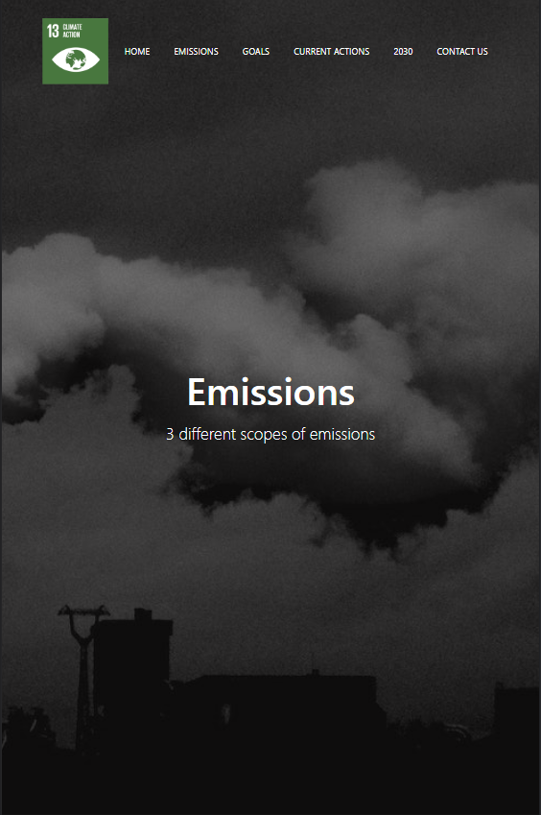

Emissions Page on Mobile

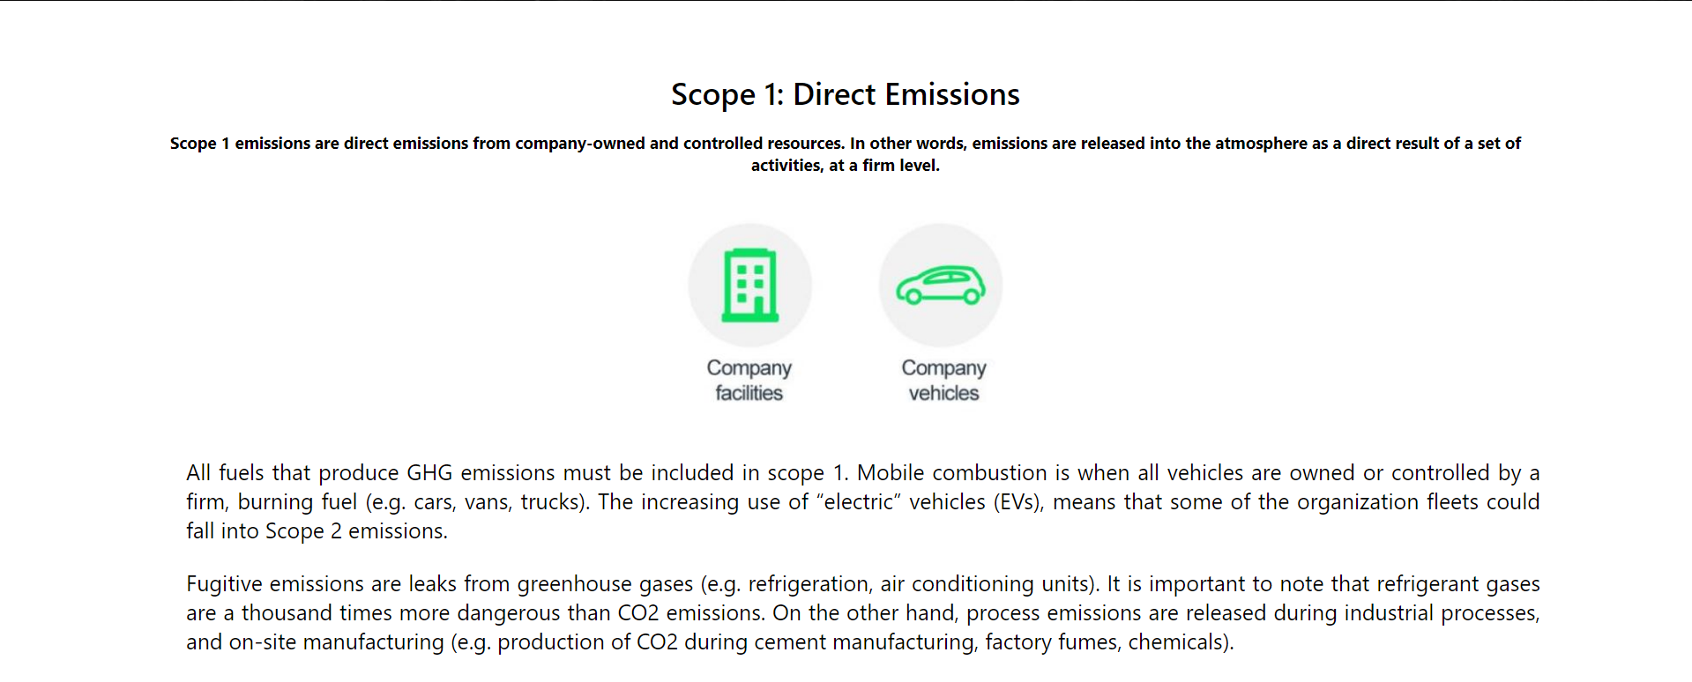

Scope 1 on PC

The first type of emissions, known as direct emissions, is described above. The image on this page serves to illustrate how company buildings and company cars contribute to climate change. This page's design prioritises clarity and a comfortable reading experience for the viewer.

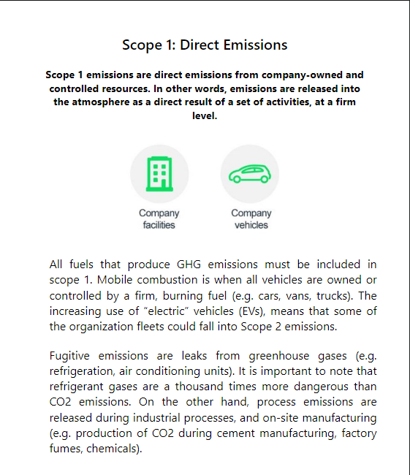

Scope 1 on Mobile

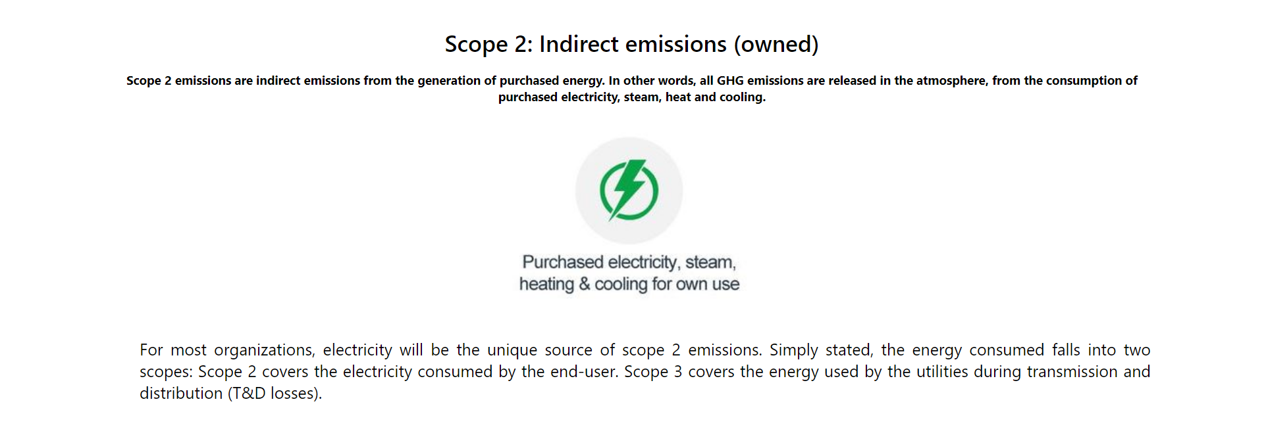

Scope 2 on PC

This page is the continuation from scope 1. The image shown above explains how indirect owned emissions affects climate change. As stated above, this page's design prioritises clarity and a comfortable reading experience for the viewer.

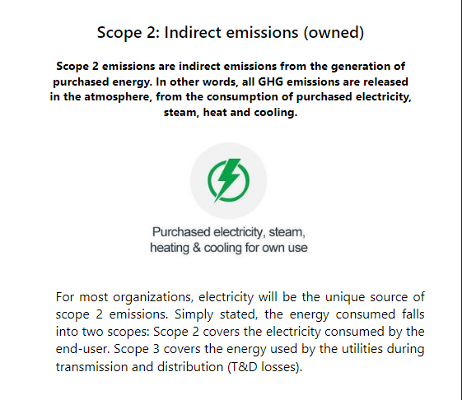

Scope 2 on Mobile

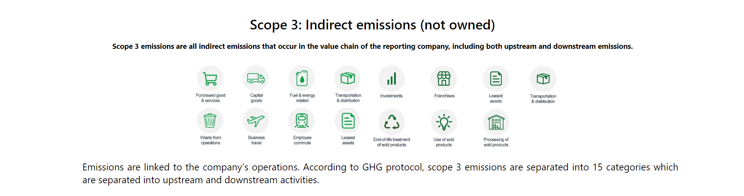

Scope 3 on PC

Above shows how indirect not owned emissions affect climate change. Every point is shown with a picture as scope 3 contains numerous examples. There are 15 total points, which are split into the categories of upstream and downstream activities.

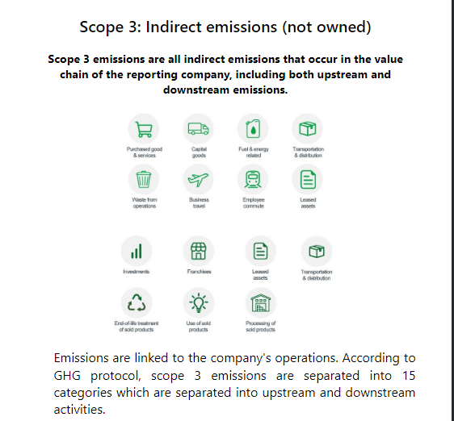

Scope 3 on Mobile

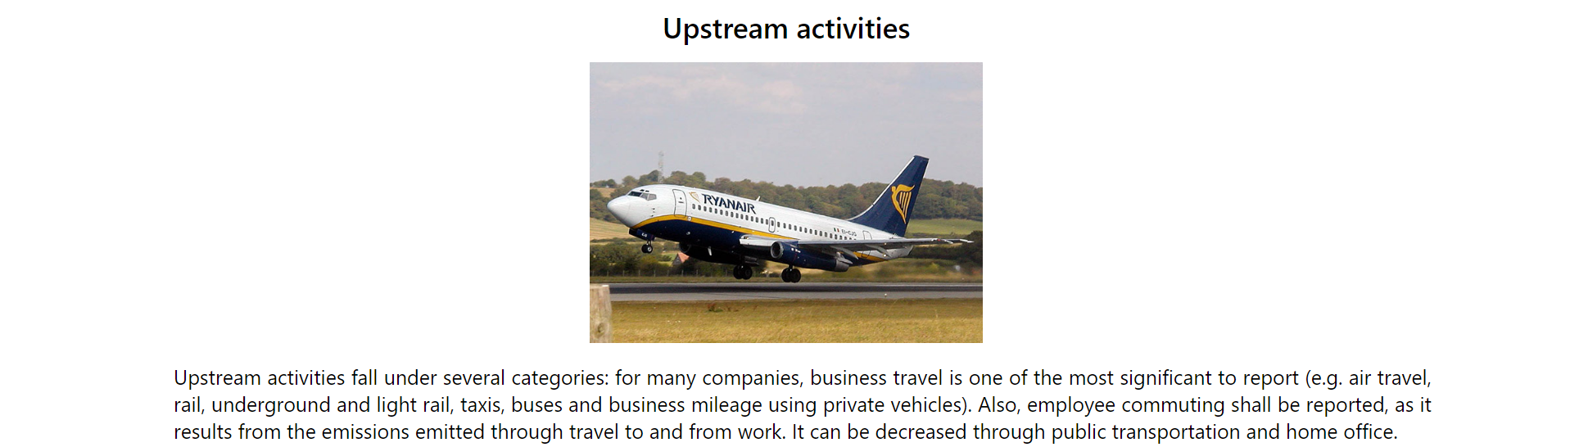

Upstream activities point 1 on PC

The information and image will be provided consistently for both upstream and downstream actions. The image chosen is to represent transportation. A bigger font heading is also above the picture to let the user know that there are 2 different categories.

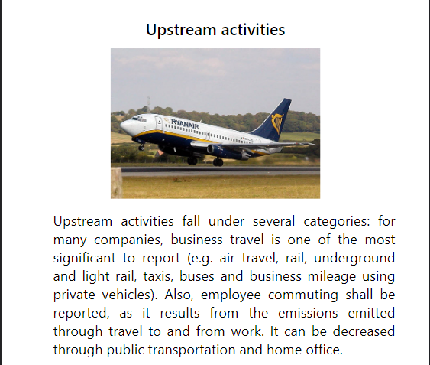

Upstream activities point 1 on Mobile

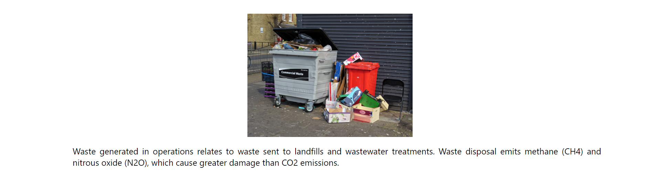

Point 2 on PC

The information and image will be provided consistently for both upstream and downstream actions. The image chosen is to represent waste disposals.

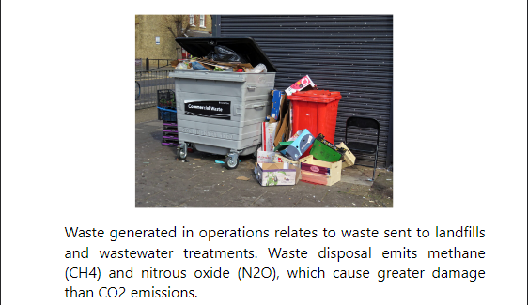

Point 2 on Mobile

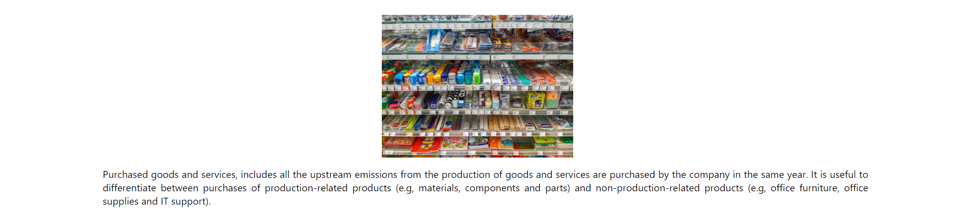

Point 3 on PC

The information and image will be provided consistently for both upstream and downstream actions. The image chosen is to represent purchased and production of goods.

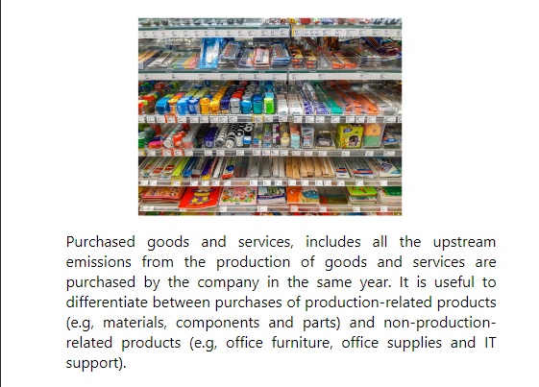

Point 3 on Mobile

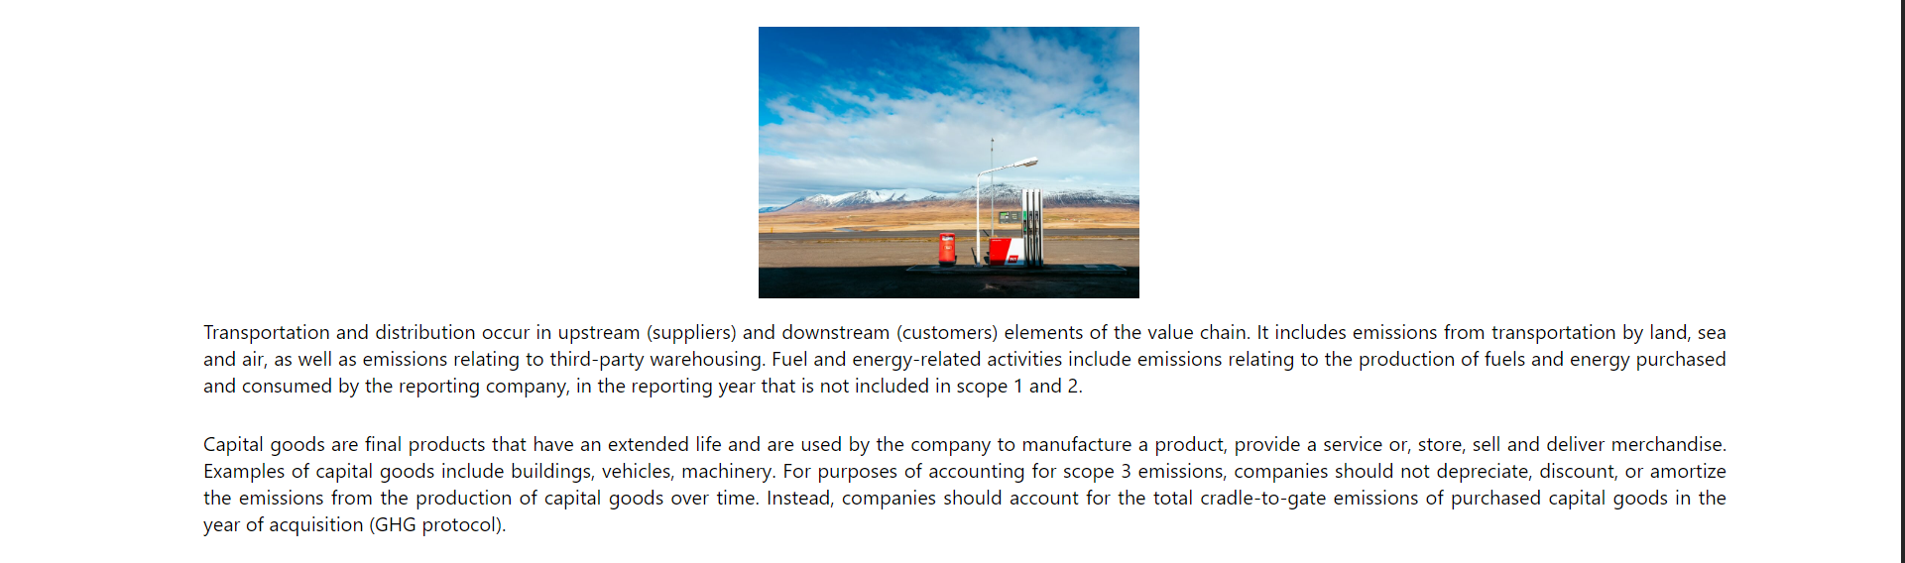

Point 4 & 5 on PC

The information and image will be provided consistently for both upstream and downstream actions. Point 4 is about fuel and energy related whilst point 5 talks about capital goods.

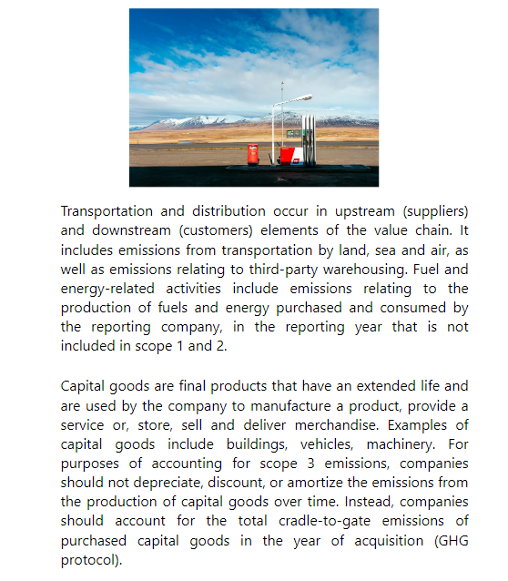

Point 4 & 5 on Mobile

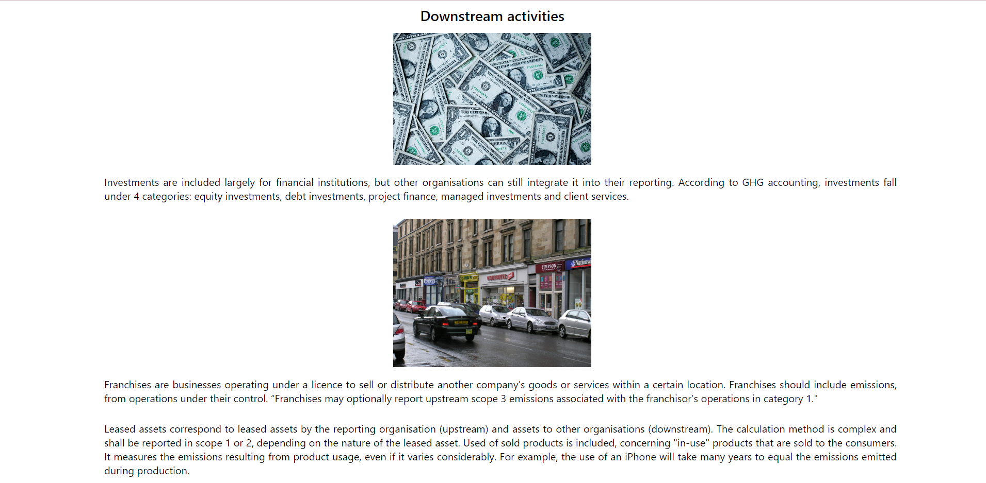

Downstream activities point 1 & 2 on PC

The information and image will be provided consistently for both upstream and downstream actions. The images chosen is to represent investments and franchises. A bigger font heading is also above the picture to let the user know that there are 2 different categories.

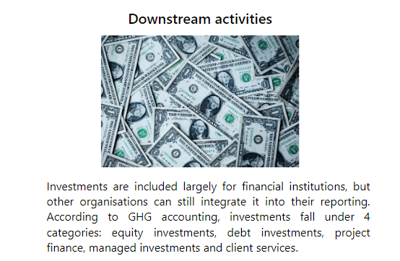

Downstream activities point 1 on Mobile

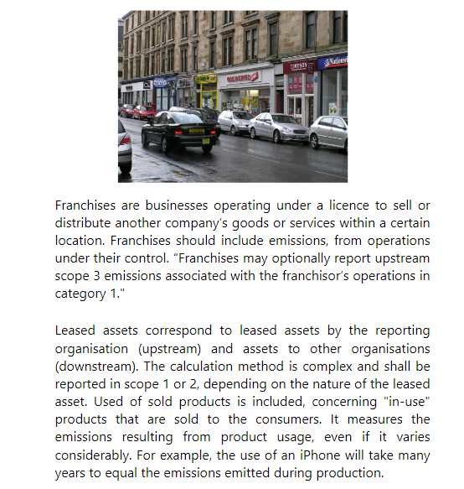

Downstream activities point 2 on Mobile

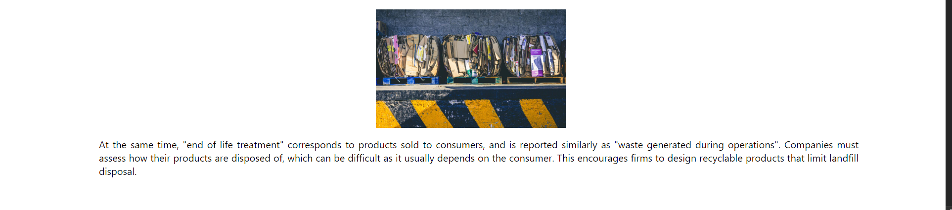

Point 3 on PC

The information and image will be provided consistently for both upstream and downstream actions. The image chosen is to represent end of life treatment.

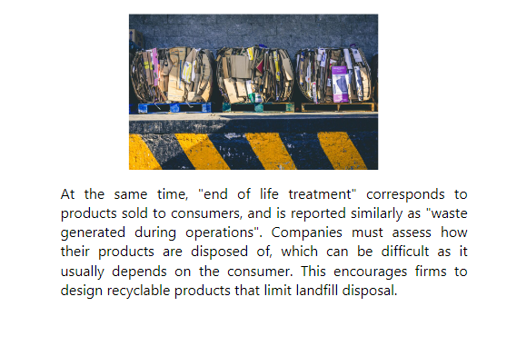

Point 3 on Mobile

Goals Page



Goals Page on PC

Image above shows the goals page of the website. On this page, five different goal 13 targets are shown.



Goals Page on Mobile

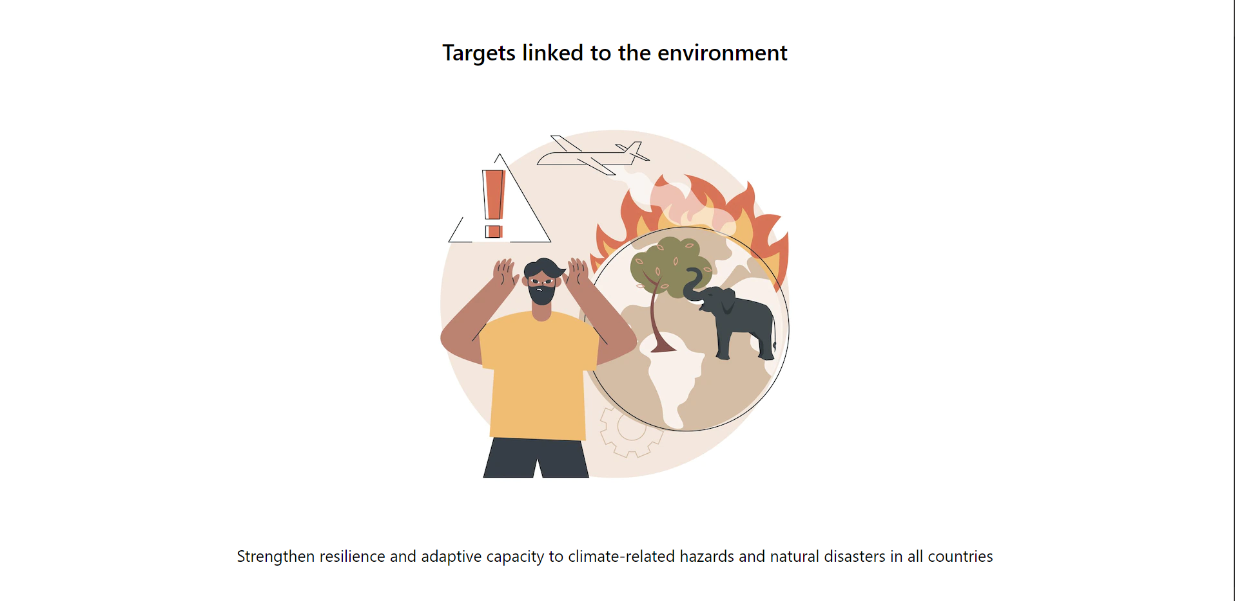

Goals Page goal 1 on PC

A bigger font heading is above the picture to let the user know that this is about targets linked to the environment. An image is also presented to keep the viewer intrigued.

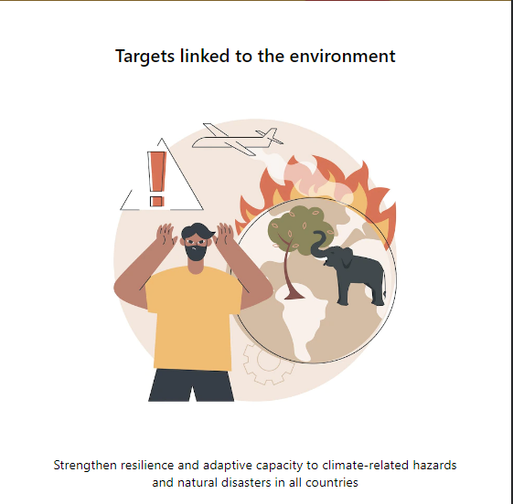

Goals Page goal 1 on Mobile

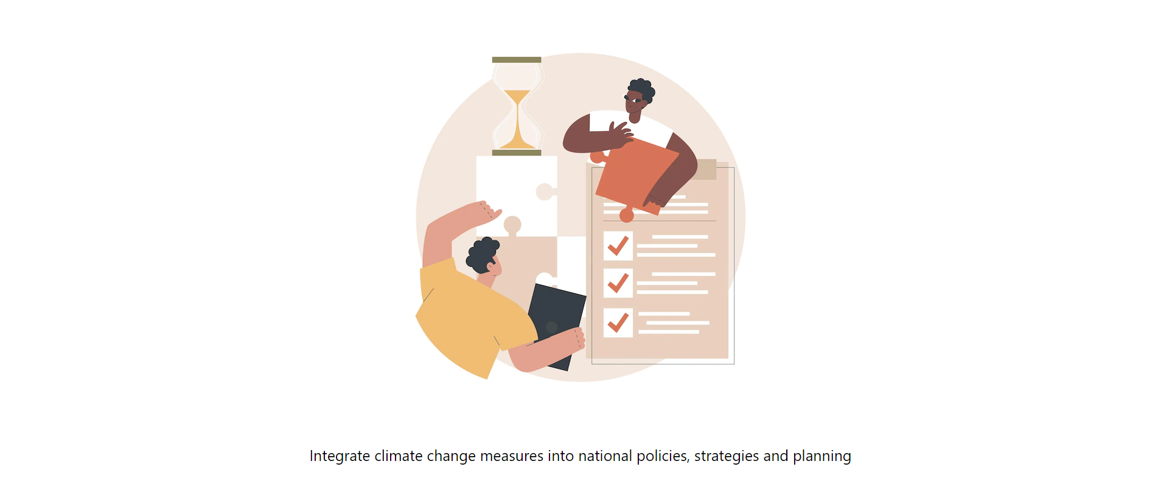

Goal 2 on PC

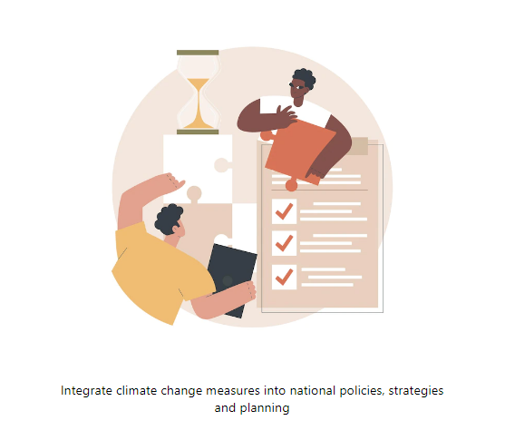

Goal 2 on Mobile

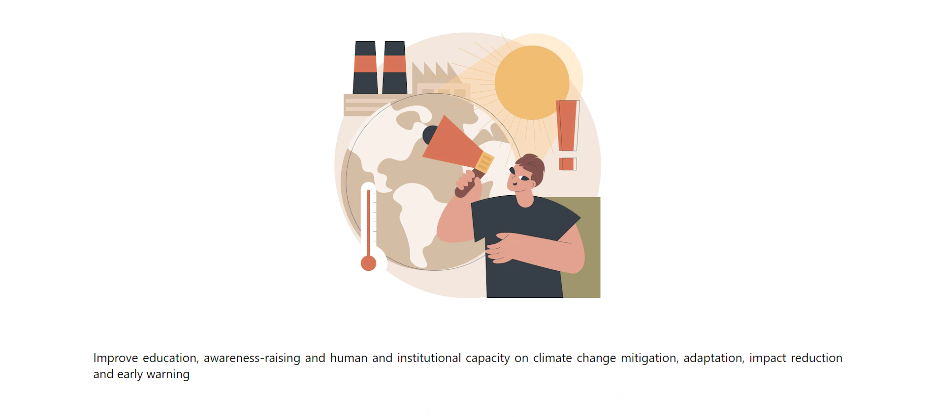

Goal 3 on PC

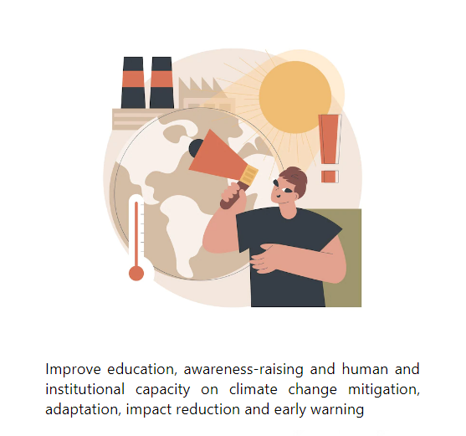

Goal 3 on Mobile

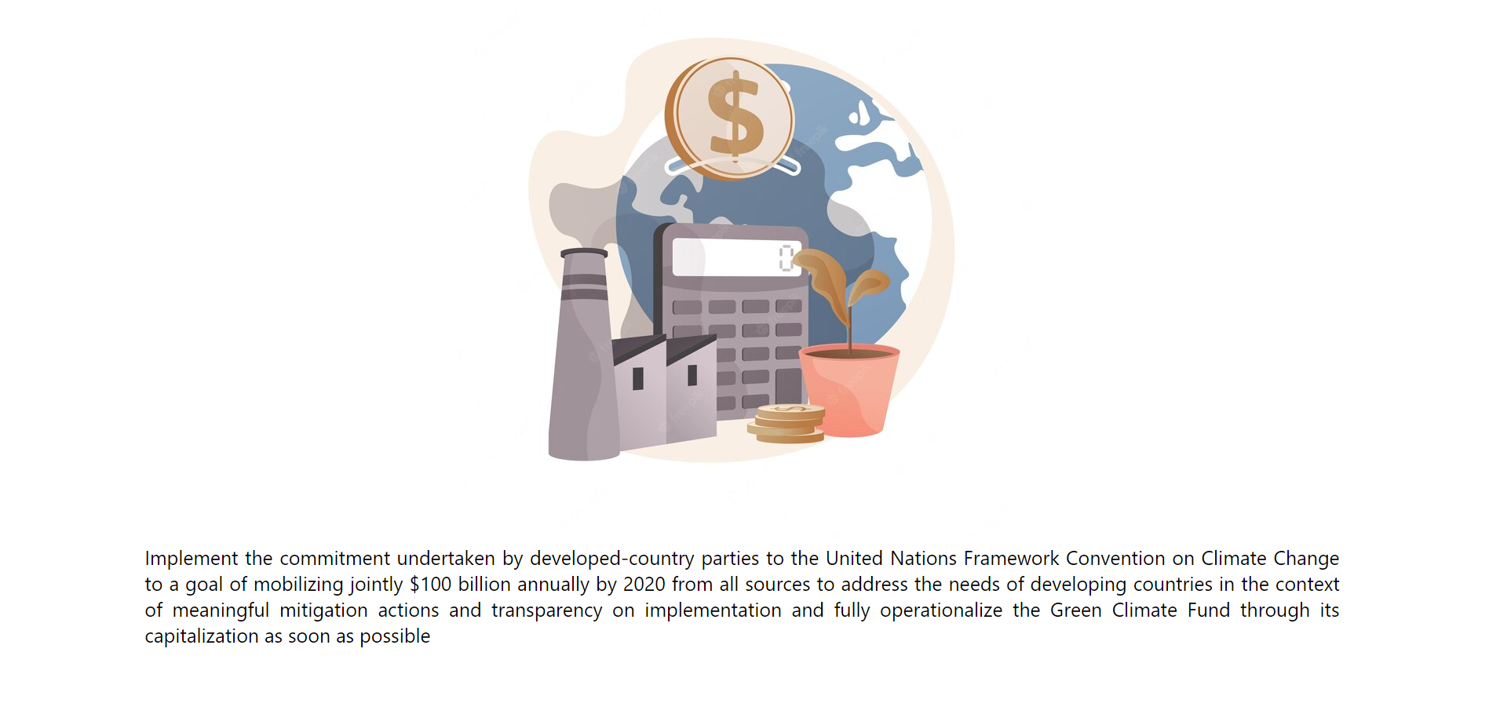

Goal 4 on PC

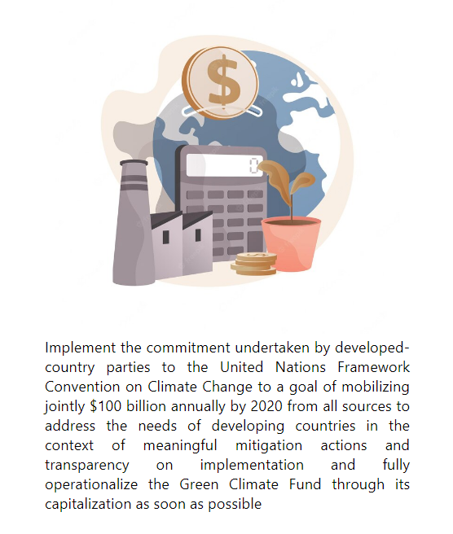

Goal 4 on Mobile

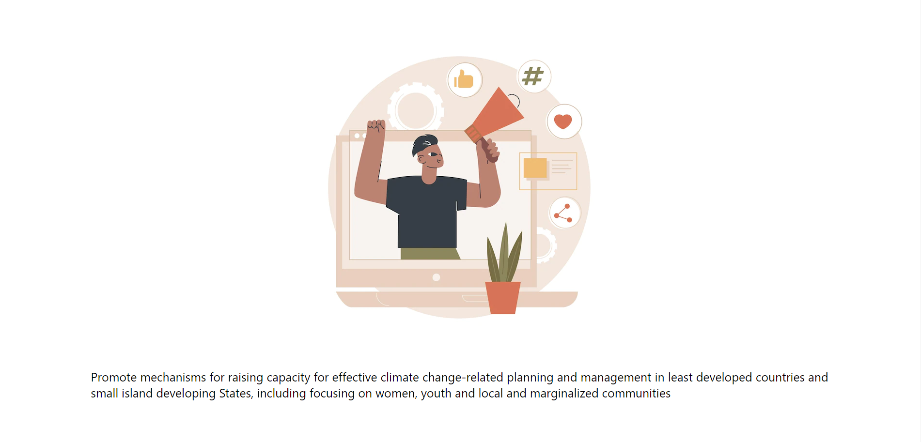

Goal 5 on PC

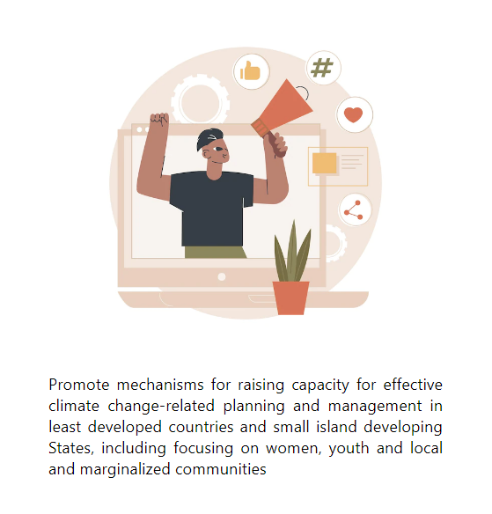

Goal 5 on Mobile

Current Actions Page

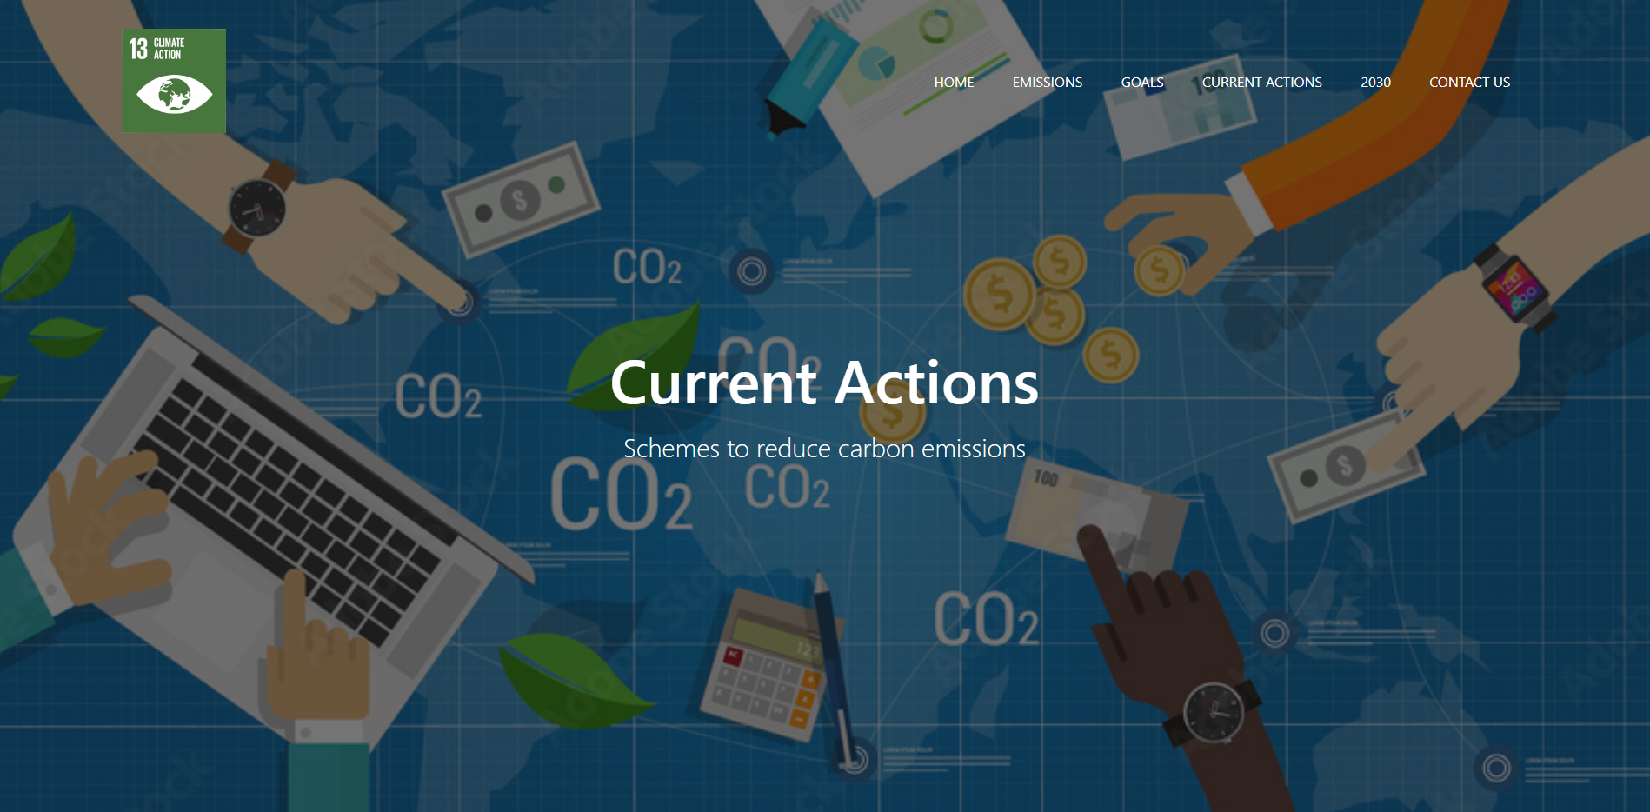

Current Actions Page on PC

Above shows the current actions page. In this page, 2 schemes to reduce carbon emissions will be explained with images.

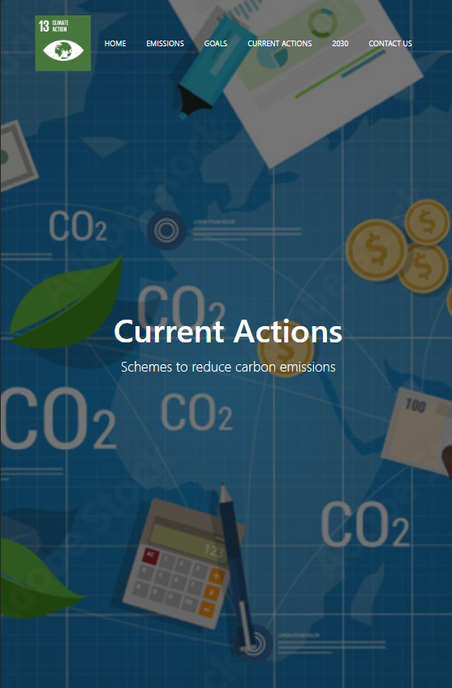

Current Actions Page on Mobile

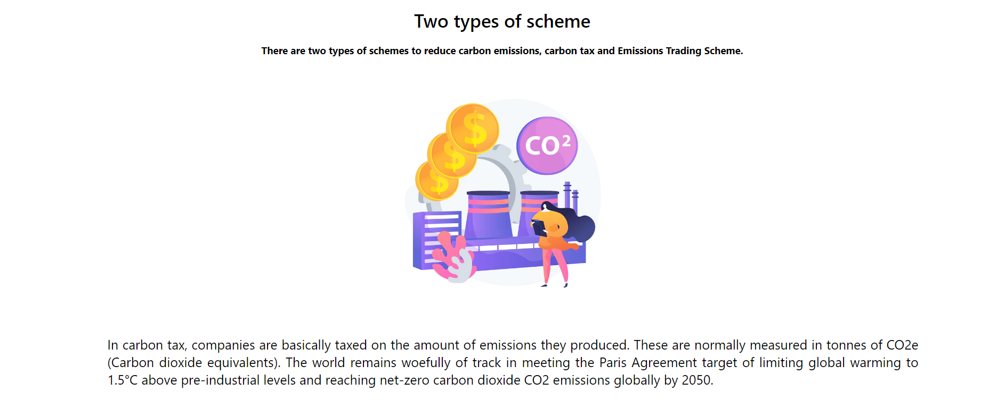

Scheme 1 on PC

The image above shows the first scheme to reduce carbon emissions. As the first scheme is carbon tax, the image picked represents carbon emissions released from a factory in form of money.

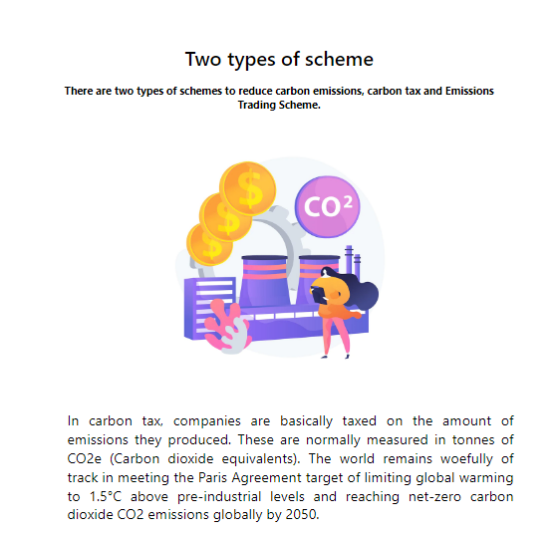

Scheme 1 on Mobile

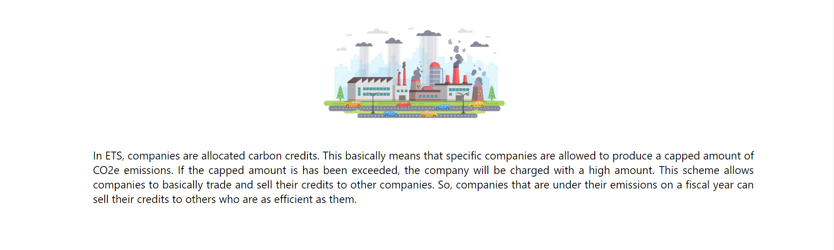

Scheme 2 on PC

Above shows the second scheme to reduce carbon emissions which is to initiate the Emissions Trading Scheme.

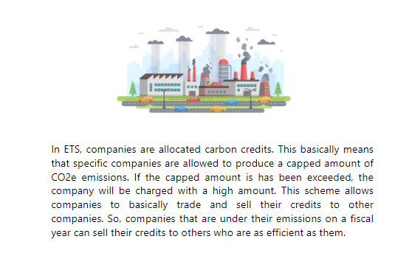

Scheme 2 on Mobile

2030 Page



2030 Page on PC

The picture above shows the 2030 page. In this page, it explains about the main purpose and objectives, key elements and how to deliver the climate target plan.

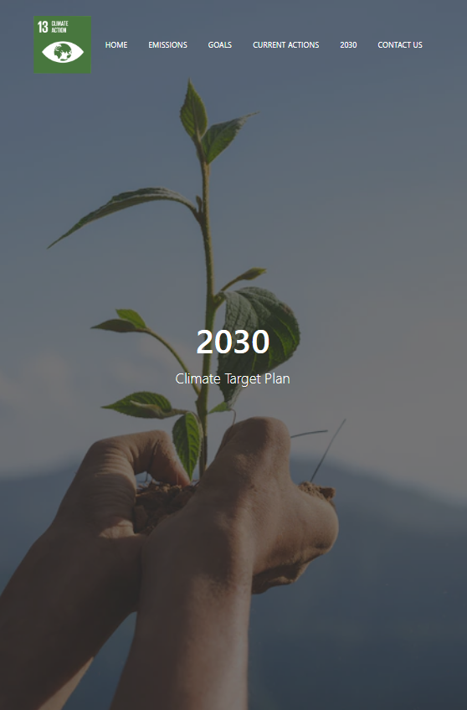

2030 Page on Mobile

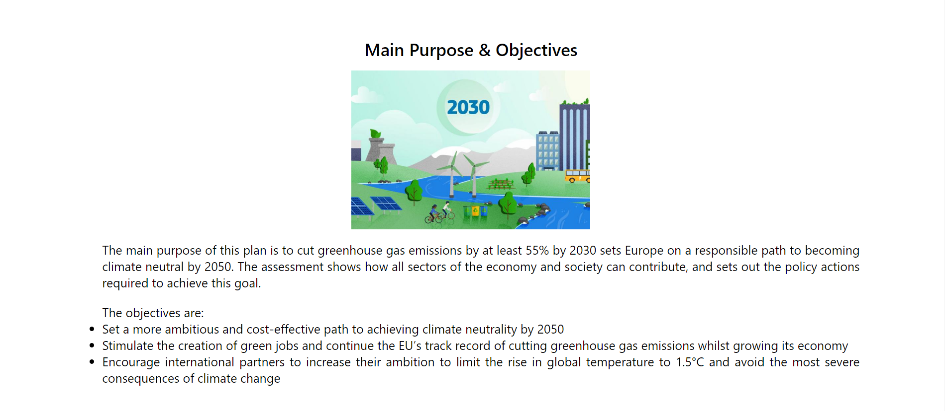

Main Purpose & Objectives on PC

The image above shows the main purpose and objectives of the 2030 plan. The objectives are shown in point form to be simple for the reader.

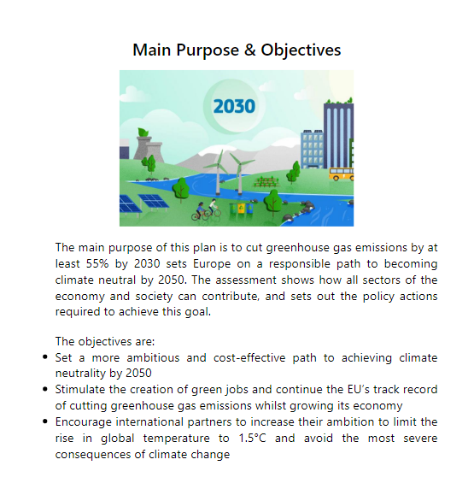

Main Purpose & Objectives on Mobile

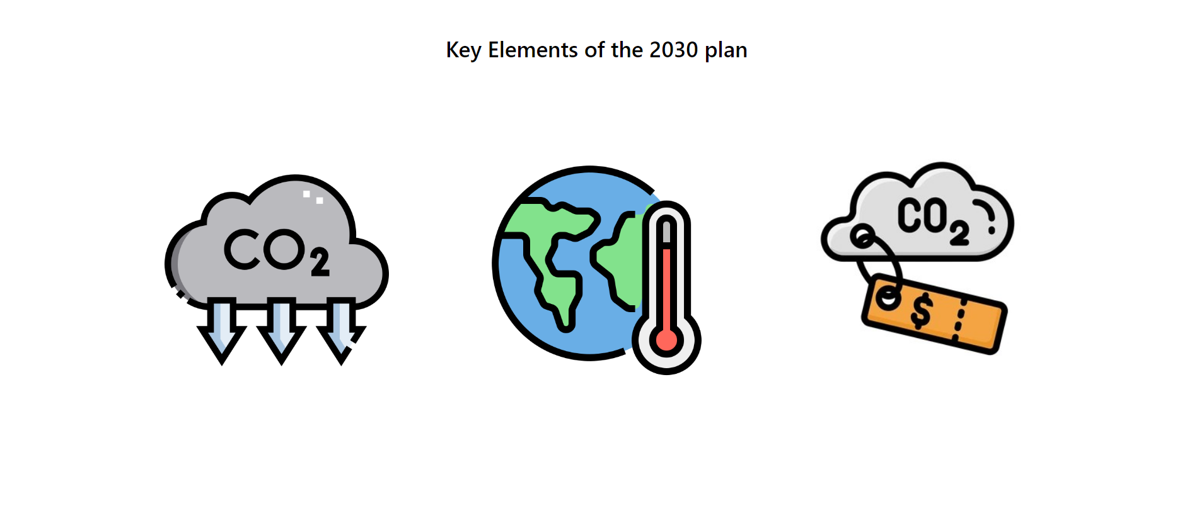

Key Elements of 2030 on PC

In the picture above, it shows 3 different images. A grey box will appear once the viewer hovers their mouse over the image and will be able to read the information shown. On the other hand, on mobile, the viewer would have to click on the image for the information to be shown.

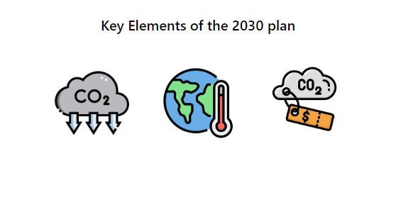

Key Elements of 2030 on Mobile

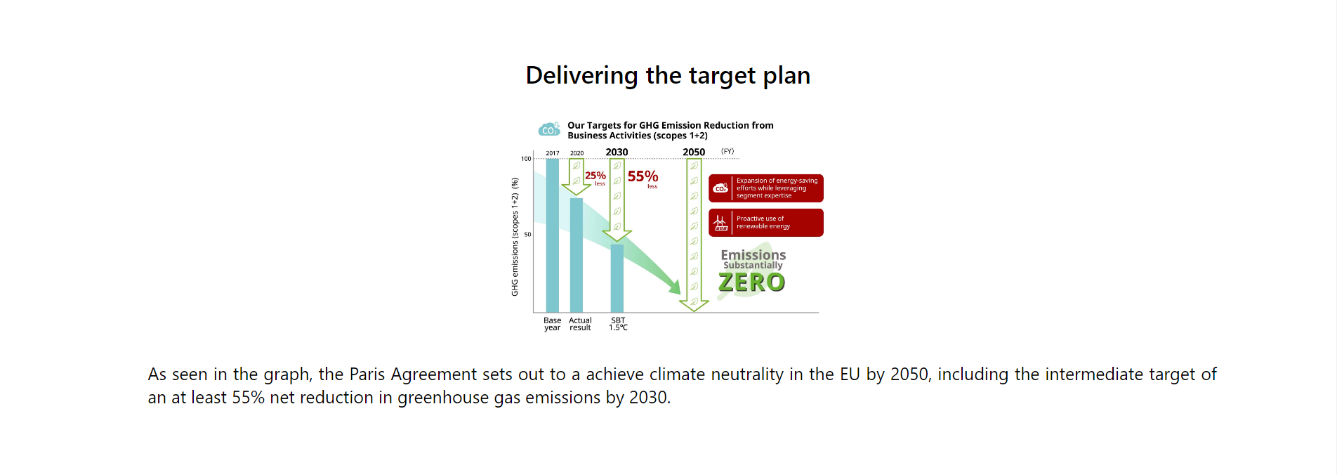

Target Plan on PC

The image above shows a graph which represents the intermediate target of an at least 55% net reduction in greenhouse gas emissions by 2030.

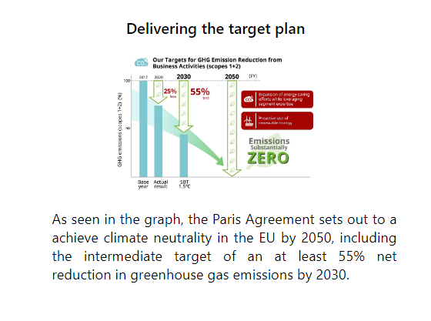

Target Plan on Mobile

Contact Us Page

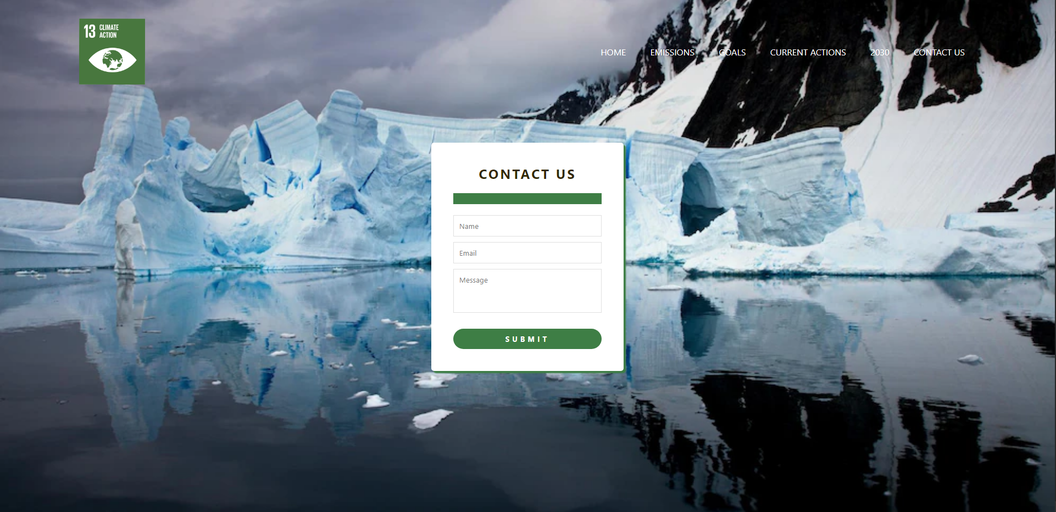

Contact Us page on PC

The image above shows the contact us form. The purpose of this form is to let us know what viewers of the website thought about the website. The form above also includes many validations which includes a name, email, and message validation which was created using JavaScript. For the email validation, the symbol ‘@’ must be included and for message and the viewer must write at least a 50-character message. If the validations are not met, an error message will appear in the green box above.

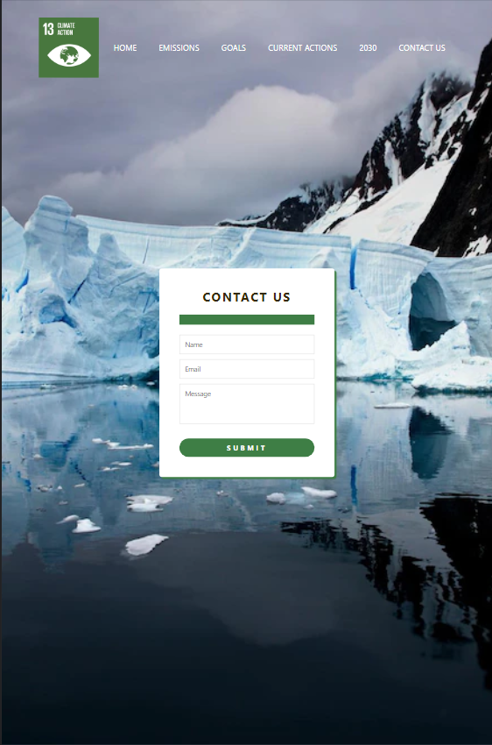

Contact Us page on Mobile

Validations

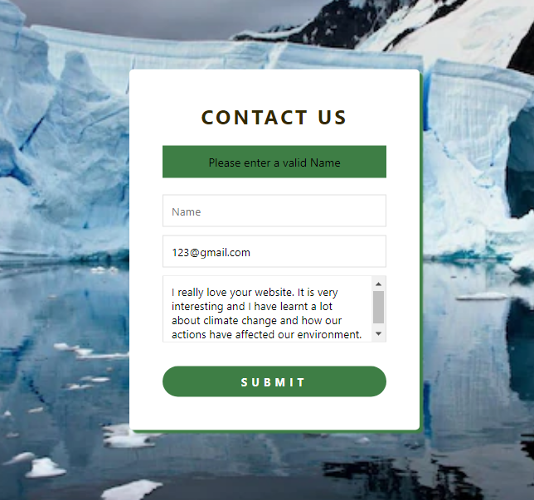

Name Validation

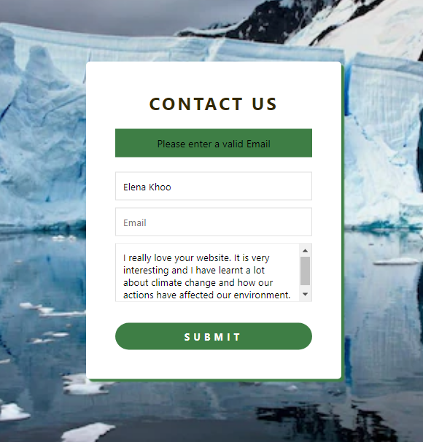

Email Validation

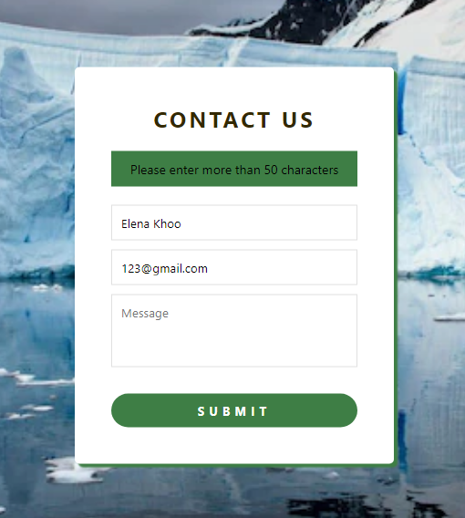

Message Validation

# 3.0 IMPLEMENTATION DETAILS

### 3.1 IMPLEMENTATION TABLE

|  |  |
| --- | --- |
| **Implemented Functions** | **Description** |
| 1. Login Function | This function is hard coded and allows the user to log in with a username and password to view the site. |
| 1. Sign Up Function | This function is hard coded and allows the user to create an account with a username, name, password, and re-enter password. |
| 1. Submit Form Function | This function uses JavaScript as it has validations. If the user inputs the correct requirements, the form will then be submitted. |
| 1. Back to Home Page Function | This function allows the user to have the convenience of going back to the home page by just simply clicking on the logo. |

The table above lists the implementation functions and description that are included on the website. These functions are added to enhance the user’s experience and to make it convenient for them.

# 4.0 TEST CASES & RESULTS

Contact Us Page

|  |  |
| --- | --- |
| **Required ID** | **Details** |
| 1. A-01 | Name |
| 1. A-02 | Email |
| 1. A-03 | Message |

|  |  |
| --- | --- |
| **Test Case ID** | TC-01 |
| **Objective** | Test if the customer can submit the form with a valid name, email, and message. |
| Required ID | A-01, A-02, A-03 |
| Condition | Must have a valid name, email, and message. |
| Test Steps | 1. Enter a valid name. 2. Enter a valid email address. 3. Enter a valid message. 4. Submit the form. |
| Input Data |  |
| Expected Results | The website will display “Form Submitted Successfully” |
| Actual Results | Matches the expected result. |
| Test Results | Successful |

|  |  |
| --- | --- |
| **Test Case ID** | TC-02 |
| **Objective** | Test if the customer can submit an empty form. |
| Required ID | A-01, A-02, A-03 |
| Condition | Each field left empty. |
| Test Steps | 1. Submit the form. |
| Input Data |  |
| Expected Results | The form will display “Please enter a valid Name” |
| Actual Results | Matches the expected result. |
| Test Results | Successful |

|  |  |
| --- | --- |
| **Test Case ID** | TC-03 |
| **Objective** | Test if the form can be submitted when the user enters a valid name and submit the form. |
| Required ID | A-01, A-02, A-03 |
| Condition | Must have valid name, but other fields invalid. |
| Test Steps | 1. Enter a valid name. 2. Submit the form. |
| Input Data |  |
| Expected Results | The form will display “Please enter a valid email” |
| Actual Results | Matches the expected result. |
| Test Results | Successful |
| **Test Case ID** | TC-04 |
| **Objective** | Test if the form can be submitted when the user enters a valid name, email and submit the form. |
| Required ID | A-01, A-02, A-03 |
| Condition | Must have valid name and email, but other fields invalid. |
| Test Steps | 1. Enter a valid name. 2. Enter a valid email. 3. Submit the form. |
| Input Data |  |
| Expected Results | The form will display “Please enter more than 50 characters” |
| Actual Results | Matches the expected result. |
| Test Results | Successful |

|  |  |
| --- | --- |
| **Test Case ID** | TC-05 |
| **Objective** | Test if the form can be submitted when the user enters a valid name, email and submit the form. |
| Required ID | A-01, A-02, A-03 |
| Condition | Must have valid name and message, but other fields invalid. |
| Test Steps | 1. Enter a valid name. 2. Enter an invalid email. 3. Submit the form. |
| Input Data |  |
| Expected Results | The form will display “Please enter a valid email” |
| Actual Results | Matches the expected result. |
| Test Results | Successful |

# 5.0 REFERENCES

(n.d.). photograph. Retrieved from https://brightest-production.s3.amazonaws.com/static/img/scope-1-2-3-emissions-carbon-accounting-ghg-protocol.jpg.

*2030 climate target plan*. Climate Action. (n.d.). Retrieved November 28, 2022, from https://climate.ec.europa.eu/eu-action/european-green-deal/2030-climate-target-plan_en

*Learn more about climate action*. SDG Help Desk. (n.d.). Retrieved November 28, 2022, from https://sdghelpdesk.unescap.org/learn-more-about-climate-action#:~:text=According%20to%20UNDP%20%2C%20climate%20action,policies%2C%20strategies%20and%20planning%3B%20and

United Nations. (n.d.). *- SDG indicators*. United Nations. Retrieved November 28, 2022, from https://unstats.un.org/sdgs/report/2021/goal-13/#:~:text=The%20world%20remains%20woefully%20off,2%20emissions%20globally%20by%202050

United Nations. (n.d.). *Climate action - united nations sustainable development*. United Nations. Retrieved November 28, 2022, from https://www.un.org/sustainabledevelopment/climate-action/

United Nations. (n.d.). *Climate change - united nations sustainable development*. United Nations. Retrieved November 28, 2022, from https://www.un.org/sustainabledevelopment/climate-change/

*What are Scopes 1, 2 and 3 of carbon emissions?* Carbon and ESG reporting for businesses. (n.d.). Retrieved November 28, 2022, from https://plana.earth/academy/what-are-scope-1-2-3-emissions#scope-1-direct-emissions

**Link to Published Website:**

[**https://github.com/elenakhoo/21012570-WEB1201-WEBSITE**](https://github.com/elenakhoo/21012570-WEB1201-WEBSITE)

**https://21012570-web1201-website.000webhostapp.com/**